Alexander Mekovsky

Lab 03

2/23/2023

COSC 320 Enyue Lu

Lab Report: I have successfully completed both tasks for this lab. I built both required trees, one made of characters, and the other made of integers. Then I ran the function that counted how many nodes in the character tree had one child, and I got two nodes. After this I ran the function that found the max value in the int character node, and got 48 as my maximum value. After looking at the two trees given, I can say that both answers are correct, starting with tree one, as node B and node E only have one child, meaning that there are two nodes with only one child. As for tree 2, the maximum value for the six nodes is 48, so the answer there is correct as well.

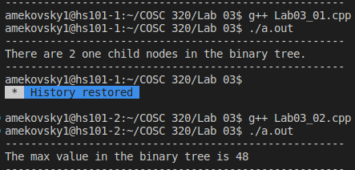
Overall it took me around two and a half hours to finish the lab. My biggest problem was at the beginning trying to set up the main function to make a character binary tree, although by the end I was able to get it working by removing the template code from the function, solving the error. As the second part was very similar to the first part, I had no issues in getting the function and code done.

